Software Testing

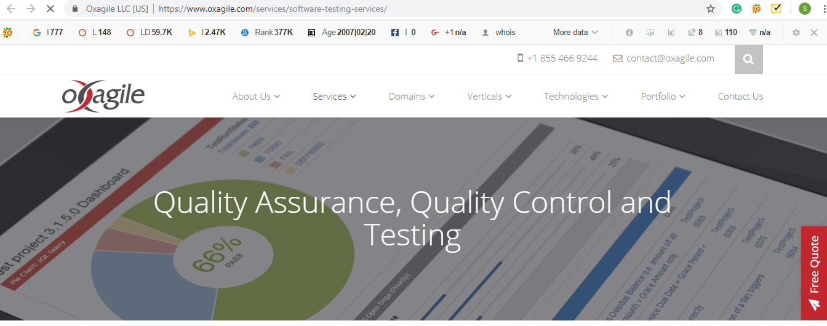

We can use this text on the image: ***Our mission is to ensure that your interactive products are bug-free and ready for publication***

Next>>

Over recent years Software Testing has experienced a seismic move in system and core interest. Gone is the time software testing and testers living in their own silo, making and executing reams of tests, performed by a group of people crosswise over different cycles before the application was ready for release. This old method for testing has an immense negative effect on the cost and timescales of a software development.

In this connected world, where competitive advantage holds tight the end-user experience instead of on singular applications, traditional testing models lack relevance. The present Testing services need to guarantee a consistent end-user experience and business process continuity over an extended network of business applications, media channels, mobile and smart devices.

**Benefits of our QA Testing Services:**

* Cost Reduction
* Improved Quality Levels
* Enhanced end user experience with the assurance of a quality-driven product
* High security and other user-centric functions
* On-Time Delivery

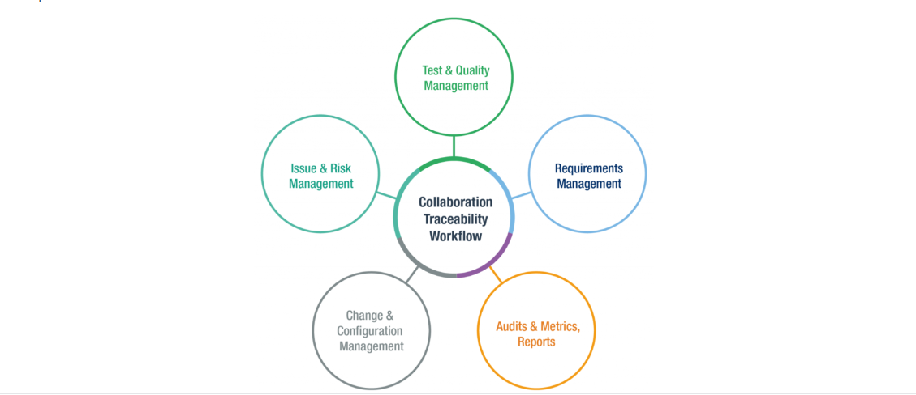

Replace the text in the image with the above 5 points

Next>>

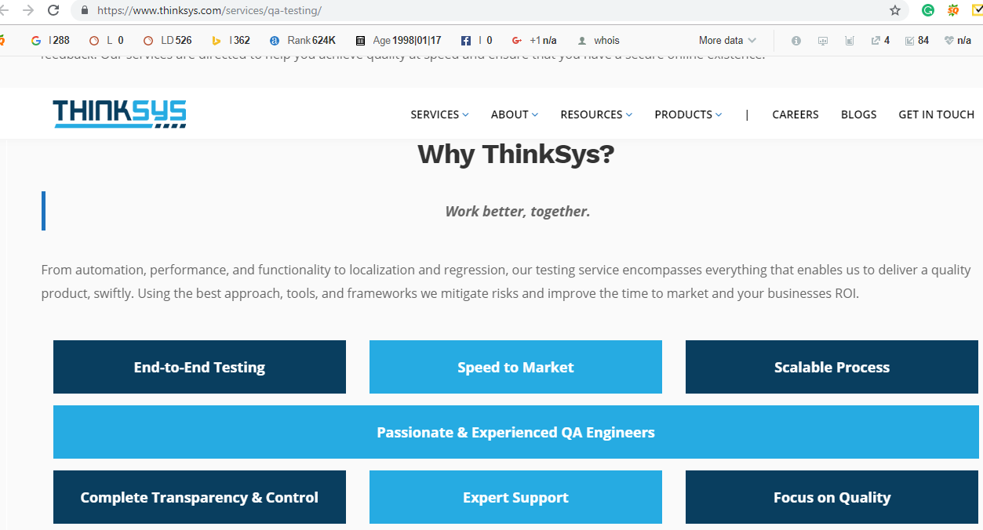

**Text to be replaced**

Why Nunc?

Nunc offers driving Quality Assurance Testing services and solutions that adhere to the highest level of testing standards for a broad range of software and hardware, leveraging advanced testing products and help clients eliminate quality issues and extract the expected value out of their IT systems, this results in significant quality improvements and a faster time to market.

**Next>> Our Approach**

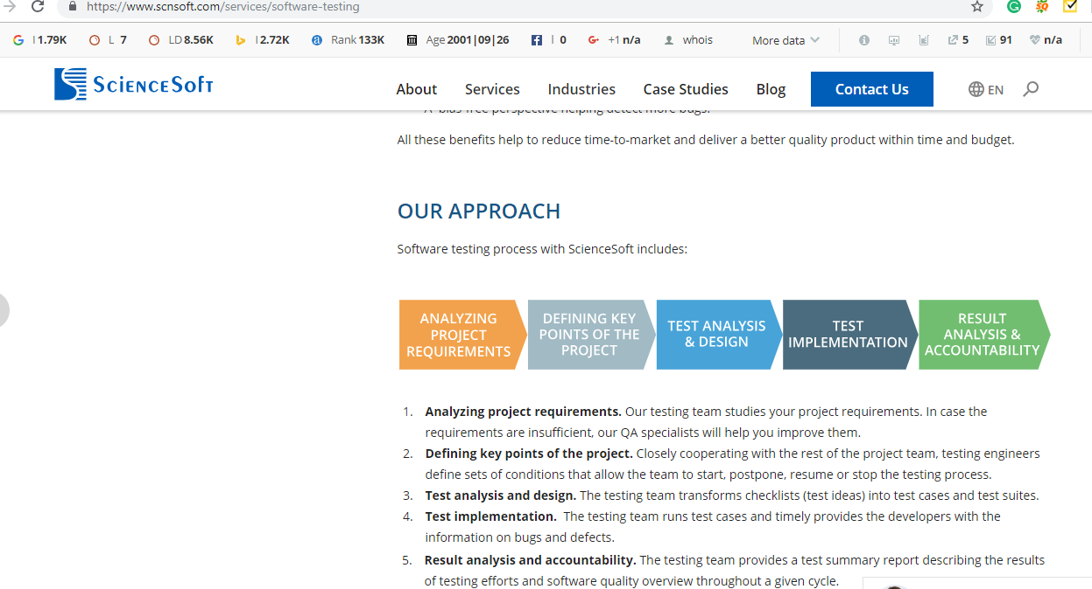

**Text to be replaced**

(Text in the boxes can be same)

1. **Analyzing project requirements:** Our Software testing team analyses your project requirements. In case the requirements are inadequate our QA experts will closely work with you to improve them.
2. **Defining key points of the project.**Closely cooperating with the rest of the project team, testing engineers define sets of conditions that allow the team to start, postpone, resume or stop the testing process.
3. **Test analysis and design.**Our testing team transforms test ideas into test cases and test suites.
4. **Test implementation.** Our testing team runs test cases and provides the developers with the info on bugs and defects.
5. **Result analysis and accountability.** Our testing team delivers a test report describing the results of testing efforts.

Our experts will assist in the entire product development life cycle from initial phase to final builds and product releases.  With our extensive capabilities in performance testing, automated testing, cloud testing and security testing, we ensure application performance is consistent with user expectations and meets benchmarked standards. NUNC works closely with our clients to help them mitigate business risks and safeguard their reputation.

**We are Expert at:**

* Functional and Non-Functional testing
* Integration testing
* Performance testing (e.g., stress, load, stability memory leak)
* Interoperability testing
* User acceptance testing (UAT)
* User interface and usability testing
* Security testing

Next>> Get a quote

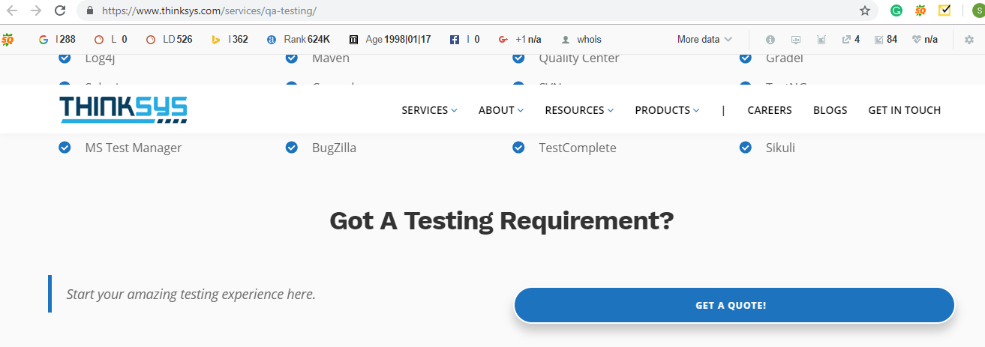

Text to be replaced

**Please do not hesitate to contact us, and a QA consultant will get back with you to discuss your testing needs.**

**-------------------------Footer-----------------------**

**Image suggestion**

[**https://www.shutterstock.com/image-vector/application-testing-concept-web-page-banner-778009627?src=dPKN_p682H0ZfRBLmkHb3w-1-0**](https://www.shutterstock.com/image-vector/application-testing-concept-web-page-banner-778009627?src=dPKN_p682H0ZfRBLmkHb3w-1-0)

[**https://www.shutterstock.com/image-vector/banner-conceptual-business-illustration-vector-icons-1106626760?src=dPKN_p682H0ZfRBLmkHb3w-1-18**](https://www.shutterstock.com/image-vector/banner-conceptual-business-illustration-vector-icons-1106626760?src=dPKN_p682H0ZfRBLmkHb3w-1-18)